PHOTOSYNTHESIS AND CELLULAR RESPIRATION
Put the following terms in the appropriate boxes: animals, carbon dioxide, chloroplasts, energy, glucose, light, mitochondria, oxygen, plants, plants, water
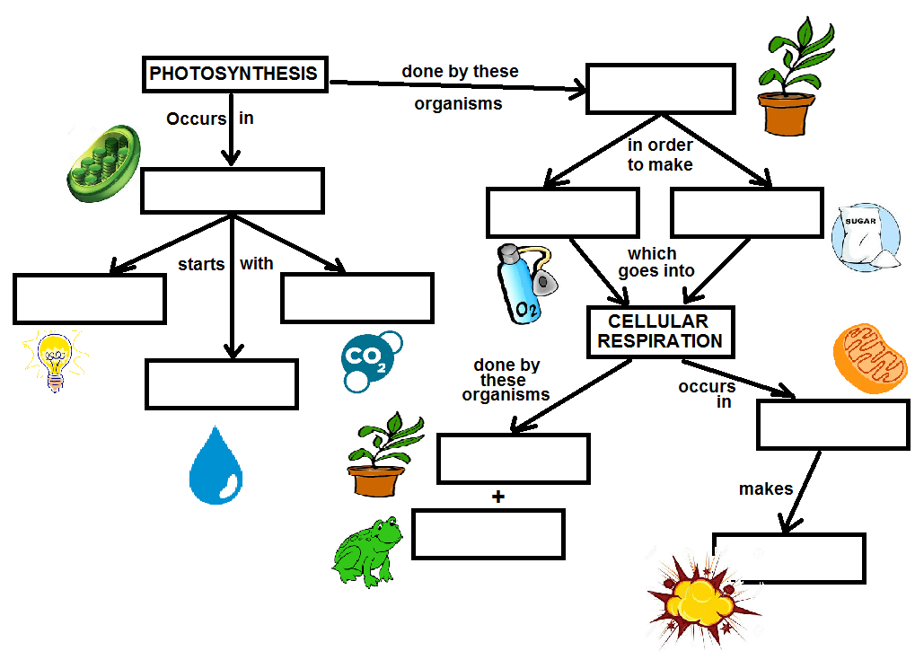
PHOTOSYNTHESIS vs. CELLULAR RESPIRATION
(refer to pg.30 and 31 in text, if necessary)
- How does a cell make its energy? Which organelle performs this function?

- Predict what would happen to a plant cell if the chloroplasts stop functioning.

- Animal cells do not have chloroplasts. Explain why.

- Why would you not find chloroplasts in an onion root cell?

- How are the equations for cellular respiration and photosynthesis related?

