Cell Analogy Project Name: _____________________

The goal of this project is to come up with an analogy for all of the organelles of a cell. Working either in pairs or individually, you will DRAW a plant cell with all of the organelles in cross section, similar to the drawing below. Then, using images cut out neatly from magazines or from google images, you will label and write a single sentence to explain how the organelle is like the image you selected.

For example: Vacuole – a vacuole is like a water bottle because it stores water and nutrients the cell might need.

The idea behind making the analogies is to force you to think about the function of the organelle in everyday terms, and the drawing makes you think about its form. The relation between form and function is one of the key concepts we need to establish in your study of biology.

Make sure to include all the organelles of the cell that are listed here: cell wall, cell membrane, cytoplasm, nucleus, endoplasmic reticulum, golgi apparatus, mitochondria, ribosome, lysosome, vesicles, vacuole, chloroplast.

The poster must be larger than 11”x12”, but not larger than 24” x 36”.

The cell must be hand-drawn and coloured, and the images must be cut out neatly. Not artistic? Trace diagrams…get creative! 3-D objects are acceptable as long as they are firmly attached to the poster and will not decay.

The project must be labelled with the analogies explained on the provided chart. Attach the chart to the poster. DUE DATE: THURSDAY, MARCH 11th
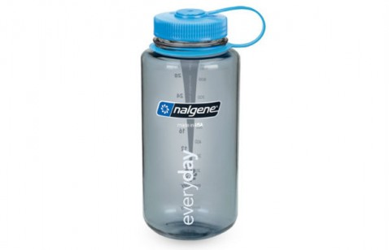
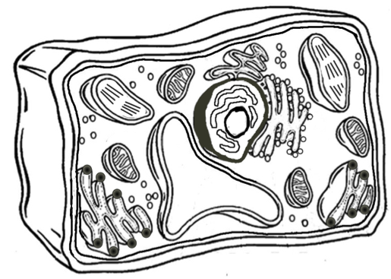
Cell Analogy Project Rubric Name: _________________________
Vacuole
The vacuole is like this water bottle because it stores water and nutrients the cell might need.

Category | A | B | C+/C | C- | I
Critical Thinking | Analogy chart is complete and all analogies are logical | Analogy chart is complete and most analogies are reasonably logical | Analogy chart is complete but some analogies are unclear | Analogy chart is mostly complete and/or many analogies are unclear | Analogy chart is incomplete
Visual Communication | Images are detailed and easy to identify.  Project is fully labelled and the chart matches the labels on the project | Most images are easy to identify.  Poster is mostly labelled or the chart mostly matches the labels on the project | Images are not easy to identify but relate to the analogy  Poster is partially labelled or the chart somewhat matches the labels on the project | Images do not relate to the analogy or several images are missing  Poster shows limited labelling or he chart does not match the labels on the project | Many images are not included  Labelling is severely lacking.
Creativity | Project has creative components, shows originality and careful planning.  The poster is exceptionally attractive in terms of design, colour, layout and neatness. | Includes appropriate components  The poster is attractive in terms of design, colour, layout and neatness. | Includes limited components  The poster is acceptably attractive although it is a bit messy | Appears to have been rushed.  The project is distractively messy or very poorly designed. | Project is illegible.

Cell Analogy Project Name: ____________________

Organelle | Analogy | Function
Cell Wall
Cell Membrane
Cytoplasm
Nucleus
Endoplasmic Reticulum
Golgi Apparatus
Mitochondria
Ribosome
Lysosome
Vacuole
Vesicles
Chloroplast

