Instantaneous vs. Average Velocity Name: _________________

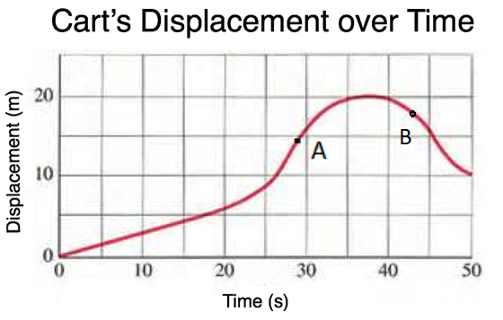
A cart’s displacement relative to a reference point is plotted against time.

a) At what time did the cart reach point A? _____
b) What was the cart’s displacement at Point A?____
c) What is the average velocity of the cart between 0.0s and Time A?

d) Calculate an estimate of the cart’s instantaneous velocity at A.

e) At what time did the cart reach point B? _____
f) What was the cart’s displacement at Point B?____
g) What is the average velocity of the cart between 0.0s and Time B?

h) Calculate an estimate of the cart’s instantaneous velocity at B.

